USER INTERFACE DESIGN EXPERIMENT – 8

NAME : DURAIMADHAN M M ROLL NO : 240701131

Create storyboards to represent the user flow for your application using Balsamiq

STORY BOARD :

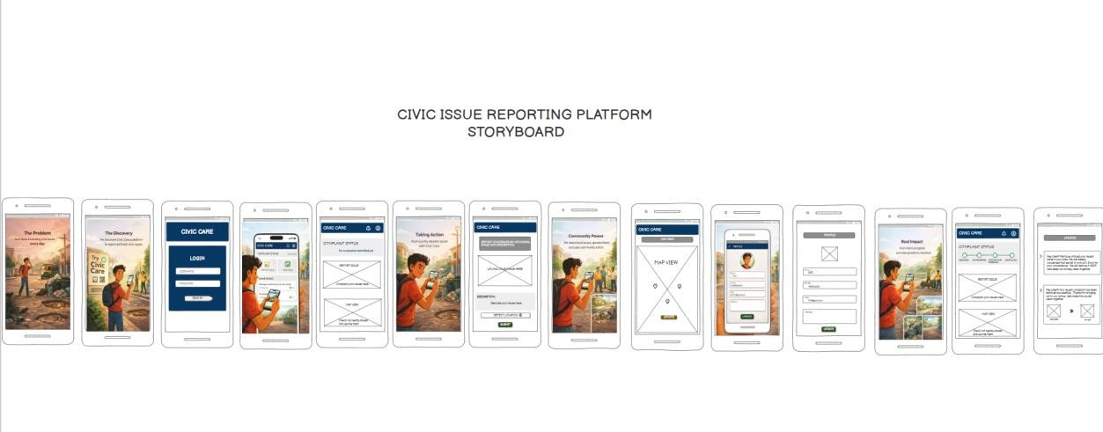

This design covers CIVIC ISSUE REPORTING platform . This design consists of

- LOGIN / SIGN-IN SCREEN
- HOME DASHBOARD
- REPORTING SCREEN
- MAP-VIEW SCREEN
- PROFILE SCREEN
- NOTIFICATION SCREEN

USER FLOW AND WORKFLOW :
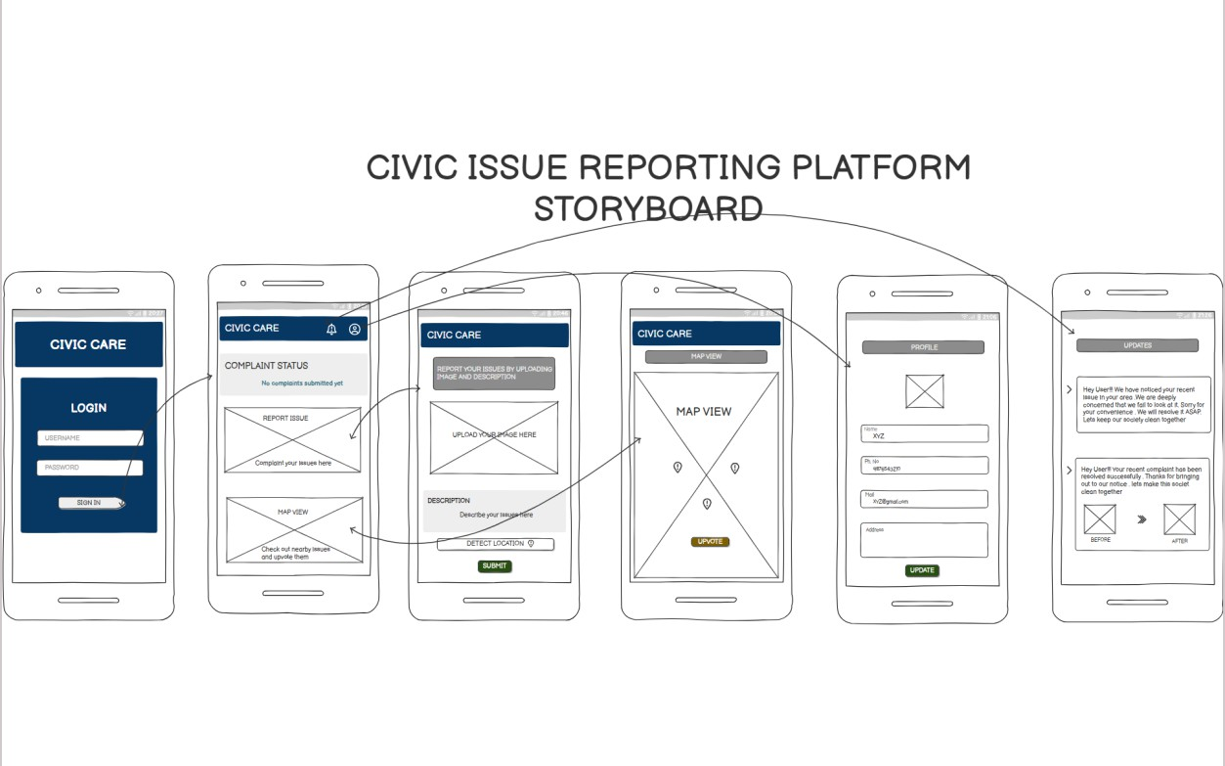

  - The user begins at the Login Screen, where they authenticate using valid credentials. Upon successful login, the user is redirected to the Home Dashboard.
  - The Home Dashboard acts as the central hub, providing quick access to key features such as:
    - Reporting issues
    - Viewing nearby complaints (Map View)
    - Notifications (Updates)
    - Profile management
  - When the user selects the Report Issue option, they are navigated to the reporting screen where they can:
    - Upload an image
    - Add a description
    - Submit the complaint
  - Selecting the Map View allows the user to explore issues reported in nearby locations and participate by upvoting existing complaints.
  - Through the Profile Screen, users can manage and update their personal information.
  - The Notification Screen provides real-time updates regarding complaint progress, including resolution status and before–after proof.

STORY CONCEPT :

The storyboard follows the journey of a user named Arun, who faces daily civic issues in his surroundings. Frustrated by the lack of action, he discovers the Civic Care platform. Through the application, he reports issues, engages with the

community, tracks progress, and eventually witnesses real-world problem resolution. This journey highlights the impact of digital civic engagement.

CONCLUSION :

The Civic Care application ensures transparency, efficiency, and community participation in resolving civic issues. The storyboard effectively demonstrates how a simple user journey can lead to meaningful real-world impact.

EXPERIMENT LINK : https://balsamiq.cloud/subh0g1/psqk8aw/rA310

